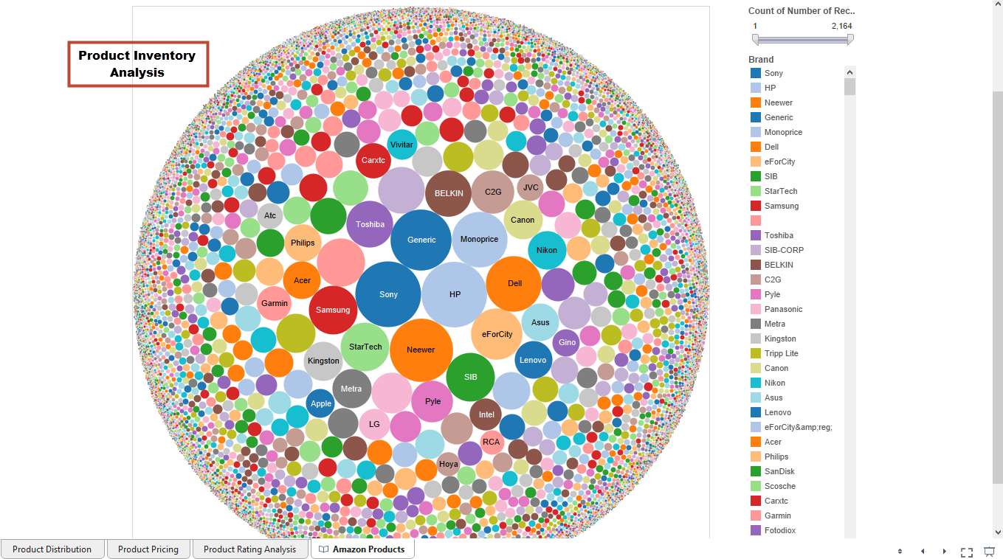

The user will be able to perform an inventory analysis using this sheet to get a high level understanding of brand distribution

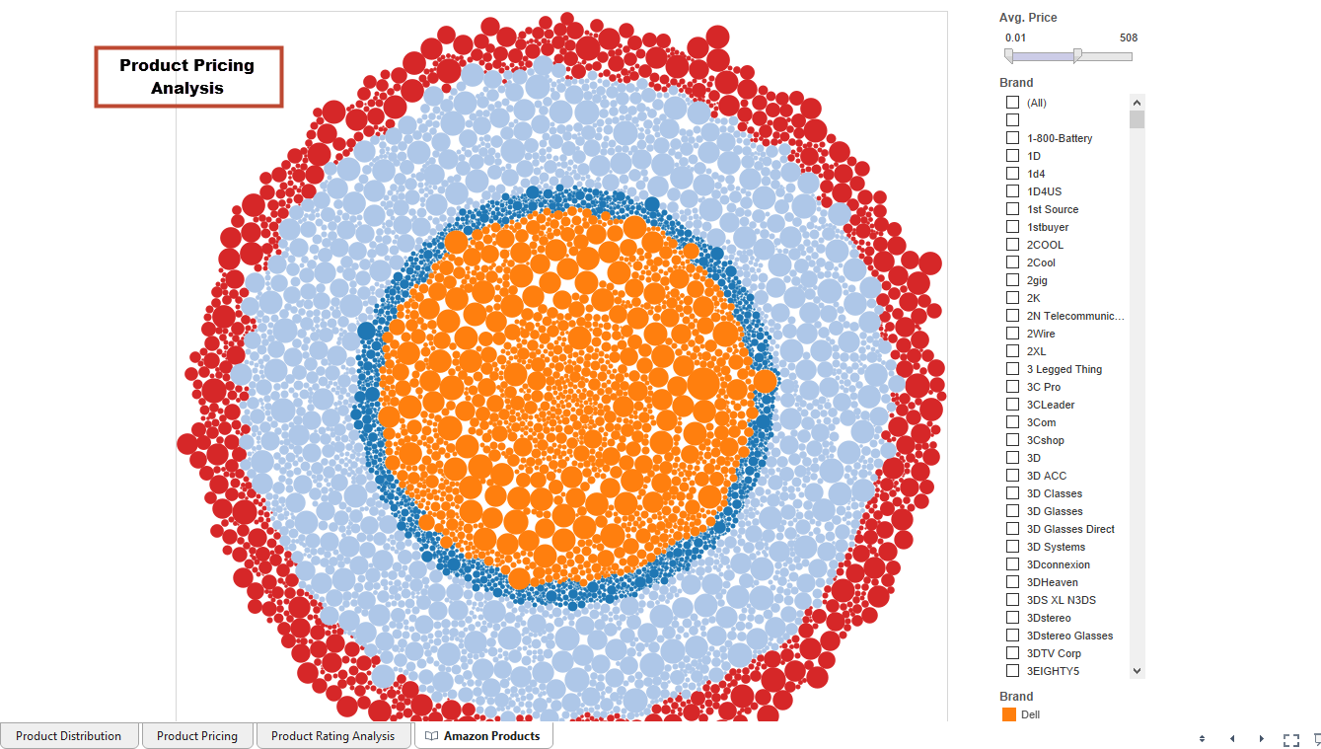

The user will be able to perform pricing analysis using this sheet to get a high level understanding of pricing

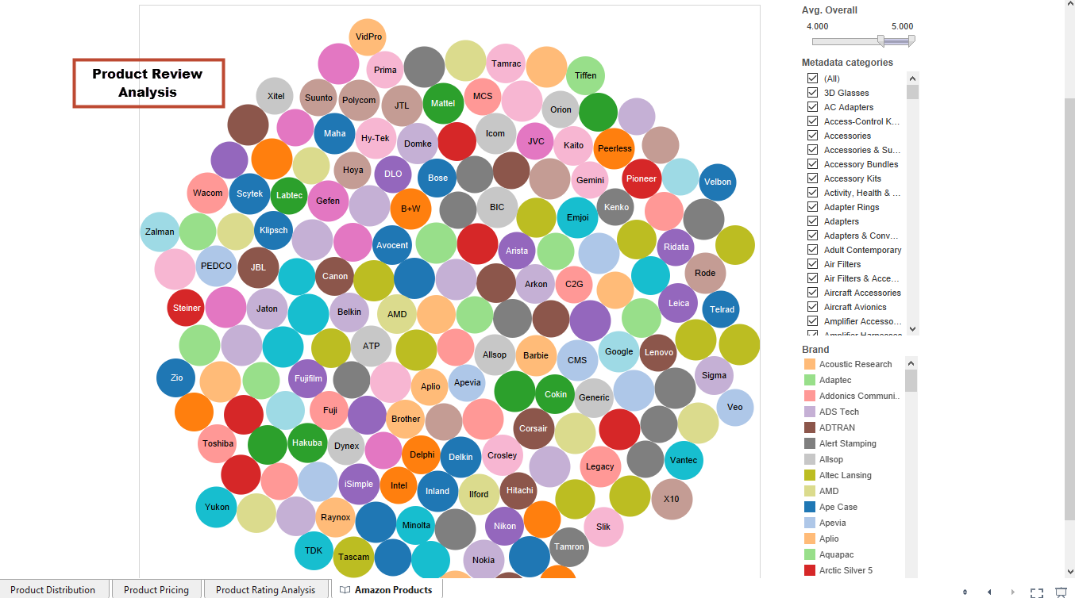

The use can use this sheet to get well received products across categories and brands.